**《Fundamentals of Electric Circuits》homework 1**

1.7 The charge flowing in a wire is plotted in Fig. 1.24. Sketch the corresponding current.

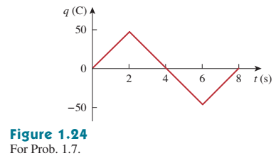

1.18 Find the power absorbed by each of the elements in Fig. 1.29.

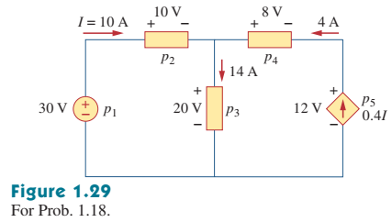

2.6 In the network graph shown in Fig. 2.70, determine the number of branches and nodes.

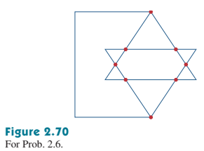

2.13 For the circuit in Fig. 2.77, use KCL to find the branch currents I1 to I4.

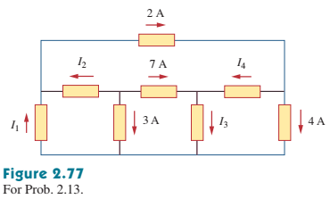

2.14 Given the circuit in Fig. 2.78, use KVL to find the branch voltages V1 to V4.

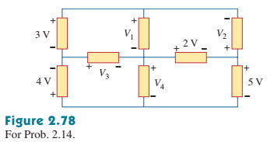

2.36 Find i and Vo in the circuit of Fig. 2.100.

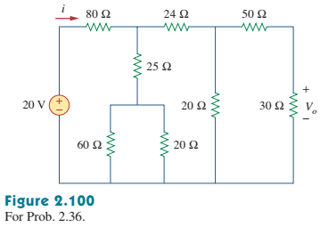

2.45 Find the equivalent resistance at terminals a-b of each circuit in Fig. 2.109.

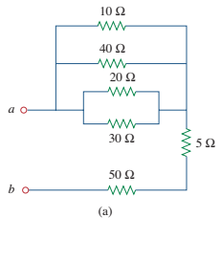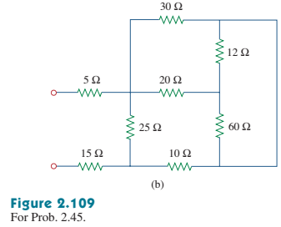

2.51 Obtain the equivalent resistance at the terminals a-b for each of the circuits in Fig. 2.115.

